Microeconomics focuses on individual decision-making units like households and firms, while Macroeconomics studies the economy as a whole. Managerial Economics applies these concepts to business decisions, guided by principles such as Incremental, Marginal, Opportunity Cost, and Equi-Marginal principles, which help managers optimize resources and maximize profits.
DIFFERENCE BETWEEN MICRO AND MACRO ECONOMICS
BASIS | MICROECONOMICS | MACROECONOMICS
Focus | Individual consumers, firms, markets | National and global economy
Key Issues | Demand, supply, pricing, production costs | GDP, inflation, unemployment, fiscal & monetary policy
Decision Level | Firm-level or household-level | National level, Government, central banks, international trade
Example | How a company sets the price of its product | How government controls inflation

Managerial Economics & Business Relevance
Managerial Economics bridges economic theory and business practice. It helps managers:
- Forecast demand and plan production.
- Set optimal pricing strategies.
- Allocate resources efficiently.
- Evaluate investment decisions.
- Minimize risks by analyzing market trends.

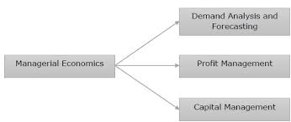
In any growing business hub, firms use managerial economics to decide whether to expand operations, invest in new technology, or adjust pricing strategies in response to local demand.
Fundamental Principles of Managerial Economics

1. Incremental Principle
- Decisions should be based on additional (incremental) costs and benefits, not totals.
- Example: A factory considers producing 100 extra units only if the incremental revenue > incremental cost.
2. Marginal Principle
- Focuses on marginal cost (MC) and marginal revenue (MR).
- Rule: Produce until MR = MC.
- Example: A retailer adds stock only if the profit from selling one more unit equals or exceeds its cost.
- Marginal cost is the additional cost incurred in producing a product whereas marginal revenue is the additional revenue made when selling one additional product.
3. Opportunity Cost Principle
• It is the cost of the next best alternative forgone.
- Example: If a company invests ₹10 lakh in machinery instead of marketing, the opportunity cost is the potential revenue lost from not investing in marketing.
4. Equi-Marginal Principle
- Resources should be allocated so that the marginal utility per rupee is equal across all uses.
- Example: A firm distributing its advertising budget across TV, social media, and print should equalize the marginal returns from each channel.

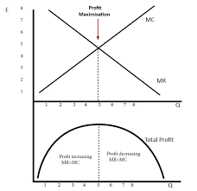
Why These Principles Matter in Business
- Profit Maximization: Helps firms decide optimal production and pricing.
- Cost Efficiency: Ensures resources are not wasted.
- Strategic Planning: Guides long-term investment and expansion.
- Risk Management: Identifies trade-offs and alternative opportunities.
.

