What is a form?
- At its core, a form is a tool for collecting and organizing information.
- It is a structured document with spaces allotted for entering data, whether it's for administrative purposes, data gathering, or record-keeping.
- Forms have an awesome ability to standardize and streamline data collection. By presenting questions or fields in a consistent format, they ensure that information is gathered systematically, making it easier to process, analyze, and store.
- This doesn’t just boost efficiency, it also reduces the likelihood of errors that can occur with unstructured data collection.
- Digital forms offer significant advantages over traditional paper forms, enhancing efficiency and accessibility by allowing quick and simple data collection from anywhere, at any time. They ensure data integrity and accuracy while staying scalable, adaptable, and eco-friendly.

The anatomy of a standard digital form
Understanding the components of a standard digital form is crucial for creating effective and user-friendly forms. Here's a quick breakdown of the most commonly used elements:

- Title and Description: The title clearly identifies the purpose of the form, while the description provides additional context or instructions.
- Input fields: These are areas where users enter data. Common types include text boxes, radio buttons, and checkboxes.
- Mandatory fields: Marked with an asterisk (*) or other indicators, these fields must be completed for the form to be submitted.
- Optional fields: These fields are not required for form submission, allowing users to provide additional, non-essential information.
- Dropdown menus: Used for selecting one option from a predefined list, making data entry quicker and more consistent.
- Date and Time pickers: Allow users to easily select dates and times, ensuring standardized input formats.
- File upload fields: Enable users to attach files, useful for submitting documents or images.
- Data validation rules: These rules ensure that the data entered matches the required format (like email addresses or phone numbers).
- Conditional fields: Appear only when certain conditions are met, based on previous user inputs, keeping the form relevant and concise.
- Submit button: The final action button, typically labeled 'Submit', 'Send', or 'Finish', to complete the form submission.
- Reset button: Allows users to clear all fields and start the form anew, useful in longer forms.
Importance of Forms:
Form is used to collect or present information into or outside from the system.
Form can be used to get input or to present output, but normally, it has been used to collect input from users.
System input has been identified during the system requirement process. A form is a business document contains predefined data and may include certain parts that need to be filled in by user.
The form should be designed to meet the purposed of the form. Designing a form, is known as user-focused activity since the development of forms should be based on user’s requirements and needs. And that’s why the use of prototyping approach is the most appropriate. Figure 10-1 shows the form and input design that should be conducted during this phase.
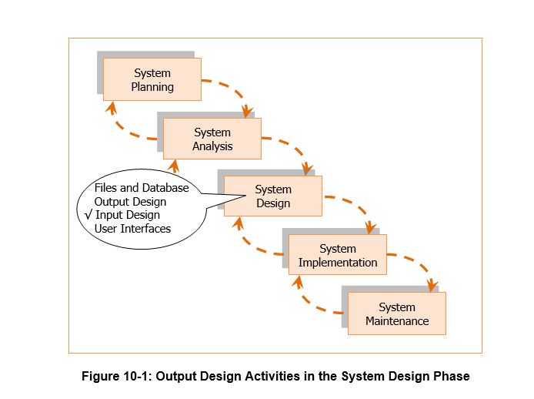

GUI CONTROLS FOR INPUT
Today, most application being developed include graphical user interface (GUI). Graphical User Interface design provides user friendly interface and also provide complex design issues. When designing input, we must consider on selecting a proper screen-based control for users to enter data on GUI screen. Here, we examine few types of common control used in GUI-based input forms. These common controls such as text box, radio button, check box, drop down list and buttons. Each of this controls have its own purpose, advantages and disadvantages. Figure 10-2 shows an example of screen-based control for input data.
