Networking Devices
1.Router
A router is a device that connects your home or office network to the internet. It sends and receives data between your local devices (like your phone or computer) and the internet. It finds the best path to send the data. The Wi-Fi box you have at home is usually a router. It lets many devices use the same internet connection.
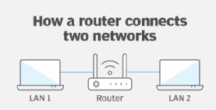

2. Switch
A switch connects many devices in a local area network (LAN), like in a school or office. It is smart because it sends data only to the correct device, not to all devices. This saves time and makes the network faster. It is better than a hub for this reason.
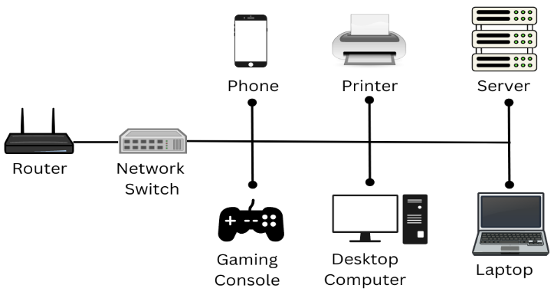

3. Hub
A hub is a basic device that also connects devices in a local network. But it is not smart like a switch. When it gets data, it sends it to all devices, even if only one device needs it. This causes extra traffic and slows down the network. That’s why hubs are not used much today.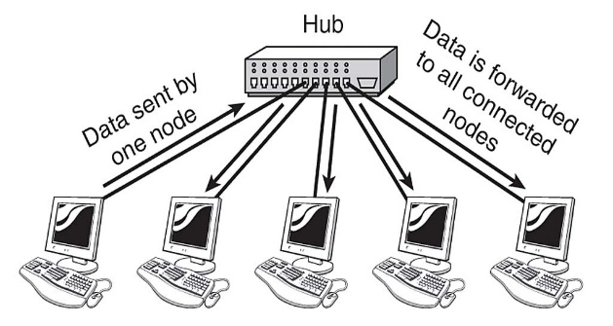

4. Modem
A modem is the device that connects your network to the internet through a telephone or cable line. It changes the digital signals from your computer into signals that can travel on wires, and changes them back when receiving data. The word "modem" comes from MOdulator + DEModulator. Most internet companies give you a modem when you get internet service.
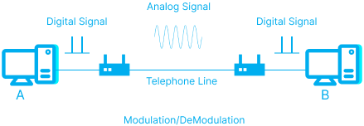

5. Repeater
A repeater is a device that boosts or strengthens the network signal. When a signal becomes weak (for example, in a large house or far from the router), the repeater picks it up and makes it strong again. This helps the signal reach far places.
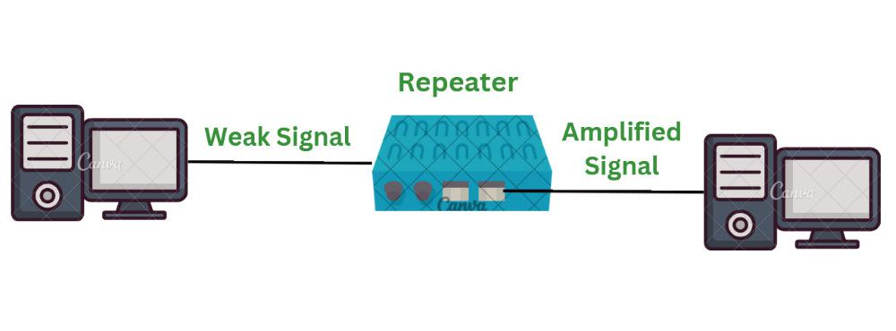

6. Bridge
A bridge connects two small networks and helps them work together like one network. It is used to divide a big network into smaller parts, making it easier to manage and less crowded. Bridges are not used as much now because switches can do the same job better.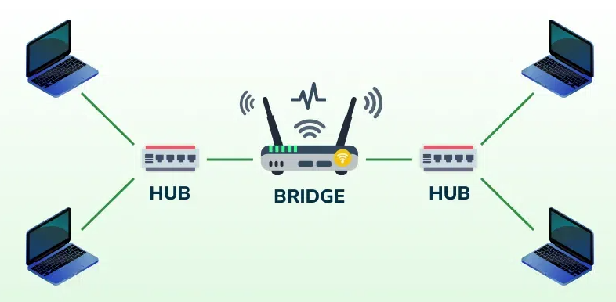
7. Gateway
A gateway connects two different types of networks. It works like a translator, helping data move between networks that speak different "languages" (protocols). A home router also works as a gateway because it connects your home network to the internet.
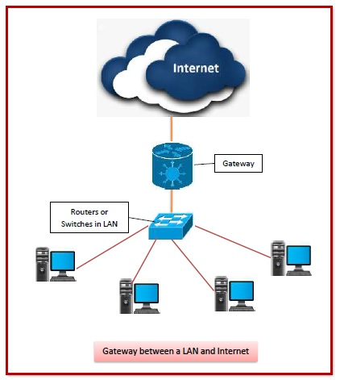

In Short:
- Router connects your home to the internet.
- Switch connects many devices and sends data only where needed.
- Hub connects devices but sends data to all (not smart).
- Modem connects to the internet using cable or phone lines.
- Repeater boosts weak network signals.
- Bridge joins small networks together.
- Gateway connects two different types of networks.

MS DOS
What is MS-DOS?
MS-DOS stands for Microsoft Disk Operating System.
It is a command-line operating system made by Microsoft. This means you type commands (text instructions) to make the computer work. It was widely used before Windows had a graphical interface.
It was first released in 1981 and was used on early personal computers.
Features of MS-DOS
- Text-based: No mouse or icons, only typed commands.
- Single-user: Only one person can use the system at a time.
- Single-tasking: Can run only one program at a time.
- Lightweight: It uses very little memory.
- File management: You can create, delete, copy, move, and rename files.
- Runs from disk: It starts from a floppy disk or hard disk.

Common MS-DOS Commands
Command | What It Does
DIR | Shows list of files and folders
CD | Changes the folder (directory)
COPY | Copies a file from one place to another
DEL | Deletes a file
MD or MKDIR | Makes a new folder
RD or RMDIR | Removes (deletes) a folder
CLS | Clears the screen
EXIT | Closes MS-DOS
FORMAT | Formats a disk
RENAME or REN | Renames a file
Uses of MS-DOS
- Used in early computers before Windows.
- Still used in booting systems, and some technical tools.
- Good for learning basic computer operations and file handling.
History
- First version: 1981 (MS-DOS 1.0)
- Microsoft used it in early versions of Windows (like Windows 95, 98).
- Later, Windows became fully graphical, and MS-DOS was no longer needed.

Linux
Linux is a free and open-source operating system.
It is like Windows or macOS, but it is based on Unix and is mostly used through the command line (although it also has graphical versions). Linux controls the computer’s hardware and lets you run software.
Linux was created by Linus Torvalds in 1991. Unlike Windows, Linux is open-source, which means anyone can see the code, change it, and share it.
Key Features of Linux
- Free and Open Source: Anyone can use it, copy it, and improve it.
- Multi-user: Many people can use the system at the same time.
- Multitasking: Can run many programs at once.
- Secure: It’s very safe from viruses and malware.
- Portable: Can run on many types of devices (PCs, phones, servers, etc.).
- Command-line and GUI: You can use Linux with typed commands or a graphical desktop like Windows.
Popular Linux Distributions (Distros)
Linux comes in different versions called distributions or distros. Some popular ones are:
- Ubuntu – User-friendly, great for beginners
- Linux Mint – Easy and similar to Windows
- Debian – Stable and powerful
- Fedora – Cutting-edge features
- Kali Linux – Used for hacking and security testing
- Arch Linux – For advanced users
Common Linux Commands
Command | What It Does
ls | Lists files and folders
cd | Changes the current directory
mkdir | Makes a new folder
rm | Deletes files or folders
cp | Copies files
mv | Moves or renames files
pwd | Shows current folder path
clear | Clears the terminal screen
sudo | Runs command with admin (root) rights
apt install | Installs software (in Ubuntu/Debian)

What Can Linux Be Used For?
- Running servers (most internet servers use Linux)
- Learning programming
- Cybersecurity and ethical hacking
- Desktop use (with GUI, like Ubuntu)
- Making apps or software
- Controlling robots or smart devices (IoT)
- Running supercomputers (most of them use Linux!)
Linux vs Windows (Basic)
Feature | Linux | Windows
Cost | Free | Paid
Source Code | Open | Closed
Security | Very Secure | Needs antivirus
Customizable | Yes | Limited
Popularity | Very popular in servers | Popular in desktops
Summary
- Linux is a free, secure, and powerful operating system.
- It’s used on everything from laptops to servers to supercomputers.
- You can use it with a command line or a desktop interface.
- It’s perfect for learning, coding, and secure computing.

