Python Programming

it is a high-level, interpreted programming language

- was created by Guido van Rossum, and released in 1991

- its main focus during creation is to provide the facility to express concepts in fewer lines of code.

- there are no type declarations of variables, parameters, functions, or methods in source code, which makes the code short and flexible, and minimizes the compile-time type checking of the source code. Python tracks the types of all values at runtime

it is case sensitive, so "a" and "A" are different variables.

- Application [5]:
- simulation and modeling (Computer Aided Design) of various machines for its testing before releasing it in the market to determine whether it is satisfying the requirement or not

  - used in programming of various machine such as Robots smart sensors
(for monitoring temperature, pressure),driverless car etc.

  - enables the machine to perform faster calculation and take decision within less time (python has the capability to analyze the massive amount of data, and taking decision in less time)

  - capacity to perform the massive calculation precisely in minimum amount
of time ,which may be error prone due to manual calculations,

  - Why Python is popular:
  - has a simple syntax similar to the English language.

  - its allows developers to write programs with fewer lines than some other programming languages.

  - variable types are determined automatically at runtime, simplifying code writing.

  - it runs on an interpreter system, meaning that code can be executed as soon as it is written. This means that prototyping can be very quick, and it is very easy to locate the error

  - it works on different platforms (Windows, Mac, Linux, etc)

Feature/ Characteristics of Python Programming Language [5]
  - Simple and Readable Syntax [MS]
  - Interpreted Language [MS]
  - High-Level Language [MS]
  - Cross-Platform Compatibility /Portability [MS]
  - Large Standard Library [MS]
  - Dynamic Typing [MS]

Python programming language
    - Integrated language [MS]
    - Free and Open Source[MS]

Simple and Readable Syntax:
    - its syntax is designed to be clear, often resembling natural language, making it easier for beginners to learn and understand. enabling them to focus more on logic building by writing comparatively fewer lines of code, rather than familiaring with complex syntax structure.

Interpreted Language:
    - its code is executed line by line by an interpreter, allowing for easier location of error as compared to the compiled language

  - High-Level Language:
    - its abstracts away complex details, allowing developers to focus on problem-solving rather than low-level system operations

Key Features of Python

Cross-Platform Compatibility/Portability :
- its applications can run on various operating systems, including

Windows, macOS, and Linux, without significant modifications
- Example, Suppose an individual have Python code for Windows and if he/she want to run this code on other platforms such as Linux, Unix, and Mac then one do not need to change it, and it can run this code on any platform.

Dynamic Typing:
- Variable types in Python are determined at runtime, meaning one do not need to advance declaration of the type of a variable, which can lead to more concise code.

Large Standard Library
- it has a large standard library that provides a rich set of modules and functions, so one do not have to write their own code for every single thing, and this allows developers to leverage existing tools and avoid reinventing solutions.

Key Features of Python

Integrated language
  - it is also an Integrated language because one can easily integrate Python with other languages like C, C++, etc.

  - It can be extended with code written in languages like C or C++. This allows for enhanced performance and the ability to use existing libraries and modules from other ecosystems within Python programs.

Free and Open Source
  - Its interpreter is developed under an open-source license, making it free to install, use, and distribute.

Famous Application Built using Python
    - YouTube: World’s largest video-sharing platform uses Python for features like video streaming and backend services.
    - Instagram: This popular social media app relies on Python’s simplicity
for scaling and handling millions of users.
    - Netflix: Python powers key components of Netflix’s recommendation engine and content delivery systems (CDN).
    - Google: Python is one of the key languages used in Google for web
crawling, testing and data analysis.
    - Uber: Python helps Uber handle dynamic pricing and route optimization using machine learning.

Advantage of python [4]:
  - Easy to Learn and Use
  - Extensive Libraries and Frameworks
  - Improved Productivity
  - Highly Secure
  - Strong Community Support
  - Cross-Platform Compatibility/Portability
  - Easier maintenance and updating of codes
  - Cost effective

Easy to Learn and Use
- Python has a simple and easy-to-read syntax to be perfect for a start in programming to continue. Unlike other programming languages which needs a lot of code structure, it allows programmers to use less code to achieve such results.
- The resemblance of Python’s syntax to natural language (like English
]5])makes it a very versatile programming language to consider for beginners and expert developers coming from another coding language expertise,

- Extensive Libraries and Frameworks

- Short and concise code:
- Python creates fewer lines of code, It enables developers to write 2-3 lines of code for a complex problem. The same problem would have needed 7 lines of code in C++ or Java

Highly Secure
- Python has built-in security features, making it suitable for applications in cyber-security and safe web programming.

- Strong Community Support
- Python has a massive and growing community of developers which gladly contributes in its development and gives guidance to learners.

- Cross-Platform Compatibility/Portability :
- Python applications can run on various operating systems, including

Windows, macOS, and Linux, without significant modifications.
- Example, if we have Python code for Windows and if we want to run this code on other platforms such as Linux, Unix, and Mac then we do not need to change it, we can run this code on any platform.

Python programming

Cost-Effectiveness
  - Python is open-source, meaning it is free to use, distribute, and modify. This cost-effectiveness makes it an attractive option for startups, educational institutions, and independent developers

Disadvantage of python programming [5]:
  - Slow Execution Speed

Slow Execution Speed:
  - being an interpreted language, it is slow compared to other compiled languages like C++ and Java.
  - Compiled languages mean that all the lines of code are converted into machine code before they are executed, making them faster compared to an interpreted language, where each line of code is executed one at a time by the interpreter.

How to print the message in the console:
    - Sol. print("Hello World")

How to print the content of the variable
- Sol. s=2.44
print(s)

Output:
2.44

How to take the input form the user and display its content?
- Sol. k = input("Please enter your name: ")
print(k)

WAP to add the numeric value and display its content on the screen.
- Sol. a=15
b=-82
c=a+b print(c)

WAP to take the input number from the user, add its value and display its content on the screen.
- Sol. a=input("Enter 1st number:") b=input("Enter 2nd number:") c=int(a)+int(b)
print(c)

Note:
  - input functions takes the string input from the user, and store it in the variable. The compiler simply consider everything (the contents of the variable, and, operator) as string and concatenates them.

  - So for converting string value into integer value, data type “int ”is used. It simply convert the string input into Integer input, and then perform the required operation.

Python Data Types

Built-in Data Types
  - Variables can store data of different types, and different types can do different operations.

  - data types are a way to classify data items. They represent the kind of value it

stores ,
•
as everything is an object in Python programming, Python data types are
classes and variables are instances (objects) of these classes.

  - Following are the basic data types of python:
- Integer
- Complex number
- Float
- Boolean

- String
- List
- Tuple
- Set
- Dictionary

- Numeric Data Types

Python Data Types

- Python numbers represent data that has a numeric value. A numeric value can be of the following types:
- an integer,
- a floating number or
- a complex number.

- these values are defined as int, float and complex classes.

Integers:
- it contains positive or negative whole numbers (without fractions or decimals).
- value is represented by int class.

Float:
- It is a real number (fractional number) with a floating-point representation. It is specified by a decimal point.
- optionally, character e or E followed by a positive or negative integer may be appended to specify scientific notation

Python Data Types
- value is represented by float class

- There are two ways to represents the floating point numbers:
- decimal representation, and
- exponential representation

Floating point representation

Decimal representation
Exponential representation/scientific representation

13, 3122,1.3129, -1.132, -4.312) 4
(20E4 = 20 * 10 =20000)

(9E-2 = 9* E -2 (2E-4 = 2* E -4
= 0.09)
=0.0002)

Python Data Types

Complex Numbers:
  - It is specified as follows:
(real part) + (imaginary part)j.

Example: - 2+3j

  - It is represented by a complex class.

Program code:
  - a=8j; b=9j

c=complex(a)*complex(b);
print(c)

Output:
  - -72

Program:
- a=5 b=43.4139
c=5+8j

print(type(a)) print(type(b)) print(type(c))

Sol:
- <class 'int'>
<class 'float'>
<class 'complex'>

String Data Type
  - are arrays (or groups) of characters.

  - In Python, there is no character data type, a character is a string of length one.

  - It can be created using single quotes, double quotes or even triple quotes.

  - one can access individual characters of a String using index

  - It is represented by str class.

Python Data Types

Program Code:

  - s = 'Welcome to Patna' print(s)

# check data type
print(type(s))

# access string with index print(s[1])
print(s[2])

Output:
    - Welcome to the Patna
<class 'str'>

e
l

List, Tuple and set:
  - allow storing of multiple values (groups of data) in an organized way

  - stores collection of items, which can be of either of similar, or different data

types.

- List Data Type
  - stores multiple values, i.e., large number of data.

  - are similar to arrays found in other languages.

  - an ordered and mutable collection of items.

  - items in a list do not need to be of the same type.

  - Creating a List in Python
  - Lists in Python can be created by just placing sequence inside the square brackets[]

Program code:
  - town = [“Patna", “Gaya", “Muzaffarpur", -3.211, 34] print(town)

print(town[1])
print(town[2])

Output:
  - [“Patna", “Gaya", “Muzaffarpur", -3.211, 34] Gaya Muzaffarpur

List is mutable:
  - the content of the list can be modified (i.e., added, or removed)
  - t=[“Patna”,”Gaya”,”Muzaffarpur”]
print(t)

Output:
  - [Patna Gaya Muzaffarpur]

  - t. append(“Buxar”) print(t)

Output:
  - [Patna Gaya Muzaffarpur, Buxar]

  - t.remove("Muzaffarpur") print(t)

Output:
  - [Patna Gaya, Buxar]

  - t.pop(1)

Output:
  - ['Patna', 'Buxar']

    - Tuple Data Type
Python Data Types

stores large number of elements (groups of data), and of any data type (like strings, integers, lists, etc.).

  - can store mixed type of data, does not necessarily of the similar type

  - only difference between a tuple and a list is that tuples are immutable, i.e., it cannot be modified after it is created.

an ordered collection of data/items

    - Creating a Tuple in Python
  - It are created by placing a sequence of values separated by a ‘comma’ with or
without the use of parentheses for grouping data sequence.

    - Program code:
  - tup2 = ('Patna', 'Patliputra', 3.9132, -6,11) print(tup2)

print(tup2[1]) print(tup2[2]) print(tup2[3])

Output:
- ('Patna', 'Patliputra', 3.9132, -6, 11) Patliputra
3.9132-6

Program to show that tuple is immutable:
  - town = (“Patna”,”Gaya”,”Muzaffarpur”) print(town)

Output:
Patna, Gaya,Muzaffarpur

town[1]=“Ara” town[2]=“Bhagalpur” print(t)

Output:
  - ‘tuple’ does not support item assignment

Boolean Data Type
  - stores one of the two values:-True or False.

  - It is denoted by class bool.

Program Code:
  - a=True; b=False; print(type(a)) print(type(b))

Output:
  - <class 'bool'>
<class 'bool'>

Set Data Type in Python
  - set is an unordered collection of data (groups of data) that is mutable, and has no duplicate elements.

  - type of elements in a set need not be the same, various mixed-up data type values can also be passed to the set.

  - order of elements in a set is undefined

Create a Set in Python:
    - it can be created by using the built-in set() function by placing the sequence inside curly braces, separated by a ‘comma’.

Program code:
  - s2 = set(["Patna", "Bihar", "India", "Patna", "Motihari"]) print(s2)

Output:
  - {'Patna', 'Motihari', 'India', 'Bihar'}

Set can also be created by using the following syntax:
town = {“Ara”,Patna”,”Gaya”} print(town)

Output:
  - {Ara, Patna, Gaya}

Set is mutable:
town = {“Ara”,Patna”,”Gaya”} print(town)

Output:
  - {Ara, Patna, Gaya}

Set is mutable:
  - town. add(“Buxar”)

Output:
  - {Ara, Patna, Gaya, Buxar}

  - town.remove(“Ara”)

Output:
  - {Patna, Gaya, Buxar}

Python Data Types
  - town.update({“Madhubani”,”Chhapra”})

Output:
  - {Patna, Gaya, Buxar,Madhubani,Chhapra}

Python Data Types

Dictionary Data Type
- dictionary in Python is a collection of data values

- a data is stored in the Dictionary in the form of a key: value pair, and each key-value pair is separated by a colon : , whereas each key is separated by a ‘comma’.

- its keys are case sensitive, the same name but different cases of Key will
be treated distinctly.

Create a Dictionary in Python:
- month= {1: 'January', 2: 'February', 9: 'September', 10:'October'}
print(month)

Python Data Types
  - values in a dictionary can be of any data type and can be duplicated,
whereas keys can’t be repeated

Program Code:
  - month = {1: ‘January', 2: ‘February', 9: ‘September', 10:‘October'} print(month)

print(d.get(9))
//Used to get the value associated with the particular key

Output:
  - {1: ‘January', 2: ‘February', 9: ‘September', 10: ‘October'} September

Dictionary is mutable:
- month = {1: 'January', 2: 'February', 9: 'September', 10:'October'} print(month)

month.pop(9) print(month)

Output:
- {1: 'January', 2: 'February', 9: 'September', 10: 'October'}
{1: 'January', 2: 'February', 10: 'October'}

- month.update({11: 'November'})
print(month)

Output:
- {1: 'January', 2: 'February', 10: 'October', 11: 'November'}

Key in the dictionary cannot be repeated
  - d = {1: 'January', 2: 'February', 9: 'September', 10:'October', 9:'July'} print(d)

Output:
  - {1: 'January', 2: 'February', 9: 'July', 10: 'October'}

value can be repeated:
  - d = { 1:’January’, 2: 'February', 9: 'September', 10: 'october', 11:'october'} print(d)

Output:
  - {'January': 1, 'February': 2, 'September': 9, 'october': 11}

the same name but different cases of Key will be treated distinctly:
- d = { 'January':1, 'February':2, 'September':9, 'october':10, 'OCTOBER':11} print(d)

Output:
- {'January': 1, 'February': 2, 'September': 9, 'october': 10, 'OCTOBER': 11}

Python Data Types

Data type

mutable
(Those data type which can be modified after creation)
Example. List, Dictionary, Sets
immutable
(Those data type which cannot be modified after creation) Example. Tuple

Operator in python

operators are special symbols that perform operations on values and variables.
  - Python categorizes operators into several groups:
  - Arithmetic Operators:
  - Assignment Operators:
  - Comparison (Relational) Operators:
  - Logical Operators:
  - Identity Operators:
  - Membership Operators:
  - Bitwise Operators

Arithmetic Operators:
  - used to perform mathematical calculations.
S. No. | Operator | Description | Example
1 | + | Addition | x + y
2 | - | Subtraction | x - y
3 | * | Multiplication | x * y

Operator in python

S. No. | Operator | Description | Example
4 | / | Division | x / y
5 | % | Modulus (remainder) | x % y
6 | ** | Exponentiation | x ** y
7 | // | Floor Division (rounds down to the nearest whole number) | x // y

Assignment Operators:
  - These are used to assign values to variables.

S. No. | Operator | Description | Example
1 | = | x = a | x = a
2 | += | x += a | x = x + a
3 | -= | x -= a | x = x – a
4 | *= | x *= a | x = x * a

Operator in python

S. No. | Operator | Description | Example
5 | /= | x /= a | x = x / a
6 | %= | x %= a | x = x % a
7 | **= | x **= a | x = x ** a
8 | //= | x //= a | x = x // a

Comparison (Relational) Operators:
  - These compare two values and return a boolean result (True or False).

S. No. | Operator | Description | Example
1 | == | Equal to | x == y
2 | != | Not equal to | x != y
3 | > | Greater than | x > y
4 | < | Less than | x < y
5 | >= | Greater than or equal to | x >= y

Operator in python

S. No. | Operator | Description | Example
6 | <= | Less than or equal to | x <= y

- Logical Operators [5]:
- used to combine conditional statements, enable to perform operations based on multiple conditions.
- used in making decision based on multiple conditions

S. No. | Operator | Description | Example
1 | and | Returns True if both statements are true | x < 5 and x < 10
2 | or | Returns True if one of the  statements is true | x < 5 or x < 4
3 | not | Reverses the result, returns False if the result is true | not(x < 5 and x < 10)

- Identity Operators [5]:
- it compare the memory locations of two objects, and determine whether they share the same memory location

S. No. | Operator | Description | Example
1 | is | Returns True if both variables are pointing towards the same memory location | x is y
2 | is not | Returns True if both variables are pointing not towards the same memory location | x is not y

- Membership Operators:
- used to test whether a specific value or item is present within the sequence (list, tuple, or set)
- it test whether the particular data is the member of something
- returns either “true”, or “false” as output.

S. No. | Operator | Description | Example
1 | in | Returns True if a value is found in the sequence | 'apple' in fruits
2 | not in | Returns True if a value is not found in the sequence | 'grape' not in fruits

Bitwise Operators [3]:
  - used to perform bitwise calculations on integers
  - integers are first converted into binary and then operations are performed on each bit or corresponding pair of bits (hence the name bitwise operators). The result is then returned in decimal format

S. No. | Operator | Name | Description | Syntax
1 | & | AND | sets each bit to 1 if both bits are 1 | x & y
2 | | | OR | sets each bit to 1 if one of two bits is 1 | x | y

S.  No. | Operato r | Name | Description | Example
3 | ^ | XOR | Decimal:  sets each bit to 1 if both the bit is different, else it returns 0  Boolean:  It returns True if and only if exactly one of the operands is True.  If both are True or both are False, it  returns False. | x ^ y
4 | << | left shift operator | shifts the bits of an integer to the left by a specified number of positions. New bits introduced on the right-hand side are filled with zeros. | x << 2
5 | >> | right shift  operator | shifts the bits of an integer to the right by a specified number of positions. Bits shifted off the right-hand side are discarded. | x >> 2

  - Example:
  - Identity operator:
  - “is” operator:
  - Program code:
  - a=42
b=42
c= a is b print(c)

“is not” operator:
  - a=42 b=312
c= a isnot b print(c)

Output:
  - True

Output:
    - True

Operator in python
- Membership Operators:
- in:
- Program code:
- fruits={“grapes”, “mango”, “apple”}
c=“grapes” in fruit
print(c)

Program code:
- fruits=[“grapes”, “mango”, “apple”]
c=“mango” in fruit print(c)

Program code:
- fruits=(“grapes”, “mango”, “apple”) c=“apple” in fruit
print(c)

Output:
- True

Output:
- True

Output:
- True

  - Membership Operators:
  - not in:
  - Program code:
  - fruit={“grapes”, “mango”, “apple”}
c=“grapes” not in fruit print(c)

  - fruit=("grape","apple","mango") c= "apple" not in fruit
print(c)

  - fruit=["grape","apple","mango"]
c= "orange" not in fruit print(c)

Output:
  - False

Output:
  - False

Output:
  - True

AND operator:
    - Code 1:
    - a = 5 # Binary: 0101
b = 3 # Binary: 0011
result = a & b # Binary: 0001 (Decimal: 1) print(result)

Code 2:
    - a = 13 # Binary:1101 b = 5 # Binary: 0101
result = a & b # Binary: 0101 (Decimal: 5) print(result)

Output:
1

Output:
5

- OR Operator:
- Code 1:

Operator in python

Output:
    - 13

- a = 13 # Binary: 1101
b = 5 # Binary: 0101
result = a | b # Binary: 1101 (Decimal: 5) print(result)

Code 2:
- a = 7 # Binary: 0111 b = 4 # Binary: 0100
result = a | b # Binary: 0111 (Decimal: 5) print(result)

Output:
- 5

Operator in python

Identity operator:
- a= variable/object
a b
42

Memory location

XOR Operator:
  - Code 1:
- a = 12 # Binary: 1100 b = 10 # Binary: 1010
c= a ^ b # Binary: 0110
print(c)

Output:
  - 6

Code 2:
- a=13 #Binary:1101 b=7 #Binary: 0111
c=a^b #Binary: 1010
print(c)

Boolean Operator:
  - a=True b=True c=a^b print(c)

Explanation:
- Assume, True =1, False =0 Result: 1 (True)
False =0, True =1 Result: 1(True)
False =0, False =0 Result: 0(False)
True =1, True =1 Result:0(False)

Output:
  - 10

Output:
- false

Shift left operator:
- Code 1:
- Sol. a = 7 # Binary: 0000 0111
c = a << 2 # Shift left by 2 positions print(c) # Output: 28 (Binary: 0001 1100)

- Explanation:

0 | 0 | 0 | 0 | 0 | 1 | 1 | 1

1 | 2 | 3 | 4 | 5 | 6 | 7 | 8

0 | 0 | 0 | 1 | 1 | 1 | 0 | 0

1 | 2 | 3 | 4 | 5 | 6 | 7 | 8

Code 2:
- a = 11 # Binary: 0000 1011
c = a << 3 # Shift left by 3 positions
print(c) # Output: 88 (Binary: 0101 1000)

Explanation:
0 | 0 | 0 | 0 | 1 | 0 | 1 | 1

Output:
- 88

1 | 2 | 3 | 4 | 5 | 6 | 7 | 8

0 | 1 | 0 | 1 | 1 | 0 | 0 | 0

1 | 2 | 3 | 4 | 5 | 6 | 7 | 8

Operator in python

Right Shift Operator (>>):
- Code 1:
- a = 28 # Binary: 0001 1100
c = a >> 2 # Shift right by 2 positions
print(c) # Output: 7 (Binary: 0000 0111)

Output:
0 | 0 | 0 | 1 | 1 | 1 | 0 | 0

- Sol:
- 7

1 | 2 | 3 | 4 | 5 | 6 | 7 | 8

0 | 0 | 0 | 0 | 0 | 1 | 1 | 1

1 | 2 | 3 | 4 | 5 | 6 | 7 | 8

- Code 2:
Operator in python

- Output:

• a = 25 # Binary: 11001 • 3
c = a >> 3 # Shift right by 3 positions
print(c) # Output: 7 (Binary: 0000 0011)

  - Explanation
0 | 0 | 0 | 1 | 1 | 0 | 0 | 1

1 | 2 | 3 | 4 | 5 | 6 | 7 | 8

0 | 0 | 0 | 0 | 0 | 0 | 1 | 1

1 | 2 | 3 | 4 | 5 | 6 | 7 | 8

Operator precedence [5]

when an expression has multiple operators , it defines order in which Python evaluates different operators in an expression

  - when an expression has multiple operators, Python follows precedence rules to
decide order of evaluation.

Example 1:
10 + 20 * 30 = 10+600 =610
Lower precedence High precedence

Code 1:
  - Sol.
a= 10 + 20 * 30
print(a)

Operator precedence

Example 2:
    - Sol.
    - x = 20 y=11
z=3
print(x == 20 or y == 13 and z >= 2)

Explanation:
  - (x == 20 or y == 13 and z >= 2)

Output:
True

High precedence

Low precedence

True or

False and

true

True or

=True
False

Operator in python

Operator Precedence:
- The precedence order is described in the table below, starting with the highest precedence at the top:
high
est
Precedence
decreases
lowest

S. No. | Operator | Description
1 | () | Parentheses
2 | ** | Exponentiation
3 | +x , -x, ~x | Unary plus, unary minus, and bitwise NOT
4 | * , /, //, % | Multiplication, division, floor division, and modulus
5 | + , - | Addition and subtraction
6 | << , >> | Bitwise left and right shifts
7. | & | Bitwise AND
8 | ^ | Bitwise XOR
9 | | | Bitwise OR

Operator in python
- Operator Precedence (Contd..)
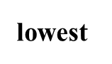

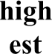

Precedence decreases
S. No. | Operator | Description
10 | == , != , >, >= , < , <= , is  , is not ,in , not in | Comparisons, identity, and  membership operators
11 | not | Logical NOT
12 | and | AND
13 | or | OR

Operator in python

Operators Associativity
- If an expression contains two or more operators with same precedence then the associativity determines how operators of the same precedence are evaluated.

Types of associativity:
- Python follows two types of associativity:
- Left to right associativity
- Right to left associativity

Left-to-right associativity:
- most operators, like +, -, *, and /, are evaluated from left to right.

Example 1:
- a= 100 / 10 * 5
print(a)

Code 2:
- result = 20 - 5 – 3 print(result) # Output: 12

Output:
- 50

  - Code 3:

Operator in python

- result = 10 / 2 * 3 print(result) # Output: 15.0

Code 4:
- result = 10 / 2 / 2 print(result) # Output: 2.5

Right-to-left associativity :
- operators like exponentiation (**) and assignment (=) evaluate from right to left.

Code 1:
- result = 2 * *3 ** 2
print(result) # Output: 512

  - Parenthesis have the highest precedence than the operator, hence it will be
evaluated first as compared to any other operands

Code 1:
- a =((2 ** 3) ** 2) print(a)

Code 2:
- a = 100 / (10 * 5)
- print(a)

Operator in python

Output:
  - 64

Output:
- 2

Executed program

Implementing assignment operator:
- Code 1:
- Sol. c=10;
c+=5;
print(c)

Implementing relational operator:
- Code 2:
- Sol. k=input("Enter 1st number:") l=input("Enter 1st number:") print(k==l)

Executed code

WAP to perform the following mathematical calculations:
  - Sol. a=input("Enter the value of a:") c=int(a)+5
print(c) d=int(a)-5 print(d) e=int(a)*5 print(e) f=int(a)/5 prin(f)

  - Output:

Executed code

Output:
    - Enter the value of a:20 25
15
100
Traceback (most recent call last):
File "/home/main.py", line 25, in <module>
prin(f)
^^^^
NameError: name 'prin' is not defined. Did you mean: 'print'?

Compiler Name:
https://www.onlinegdb.com/online_python_interpreter

  - These are the decision making codes

  - Following are the various types of decision making codes:
- Conditional statement
- Looping, and

Conditional statement:
- used to execute certain blocks of code based on specific conditions.

- allow us to check for certain conditions and perform actions based on the

outcome of those checks

- these statements help control the flow of a program, making it behave differently in different situations

Types of conditional statement [4]:
- If
- If else

- elif
- Ternary Expression
- Nested if..else

    - If [4]:
  - It executes a block of code if the given condition is true.

  - Syntax:
if (condition):
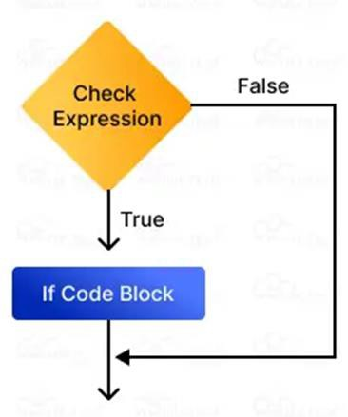
statement #this statement will execute only if the condition is true

Example
  - age = 65
if age >= 18:
print("Eligible to vote.")

Output:
Eligible to vote Figure 1: If Statement flow control

If else [4]:
- allows us to specify a block of code that will execute if the condition(s) associated with an if statement evaluates to False.

- If the condition is true, statement inside the “if block” will be executed,
otherwise statement inside the “else block” will be executed.

Syntax:
if condition:
statement1 #this statement will execute only if the condition is true
else:
statement2 #this statement will execute only if the condition is false

Example:
- age = 10
if age <= 18:
print("not eligible for vote")

Output:
- not eligible for vote

else:
print("eligible for vote")

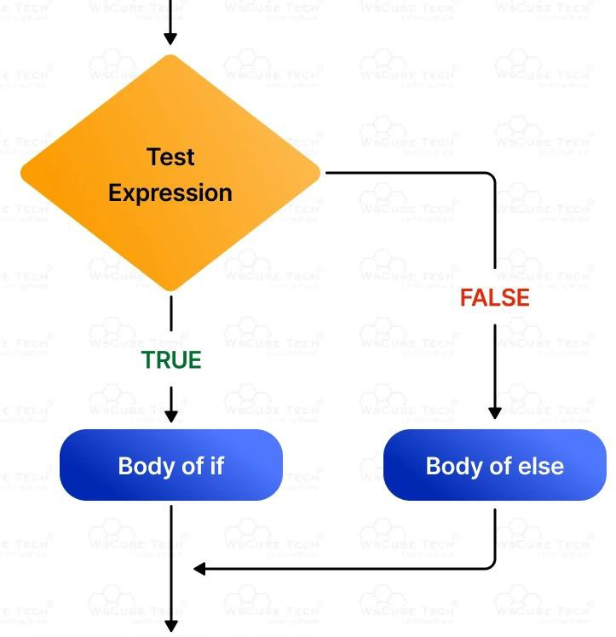
•
fa

Figure 2: flow chart of if-else
condition

- elif Statement/else if [4]:
- stands for "else if."

- it allows us to check multiple conditions, providing a way to execute different

blocks of code based on which condition is true.

- Syntax:
if (condition1):
statement1 #this statement will execute only if the condition1 is true elif(condition2):
statement2 #this statement will execute only if the condition1 is false and condition2 is true
elif(condition3):
statement3 #this statement will execute only if the condition1&2 is false and condition3 is true
elif(condition4):
statement4 #this statement will execute only if the condition1&2,3 is false and condition4 is true
else:
statement4 #this statement will execute only if all the above mentioned condition is false

Example:
  - age = 21

if age <= 12:
print("Child.") elif age <= 19:
print("Teenager.")
elif age <= 35:
print("Young") else:
print("Adult.")

Output:

  - Young

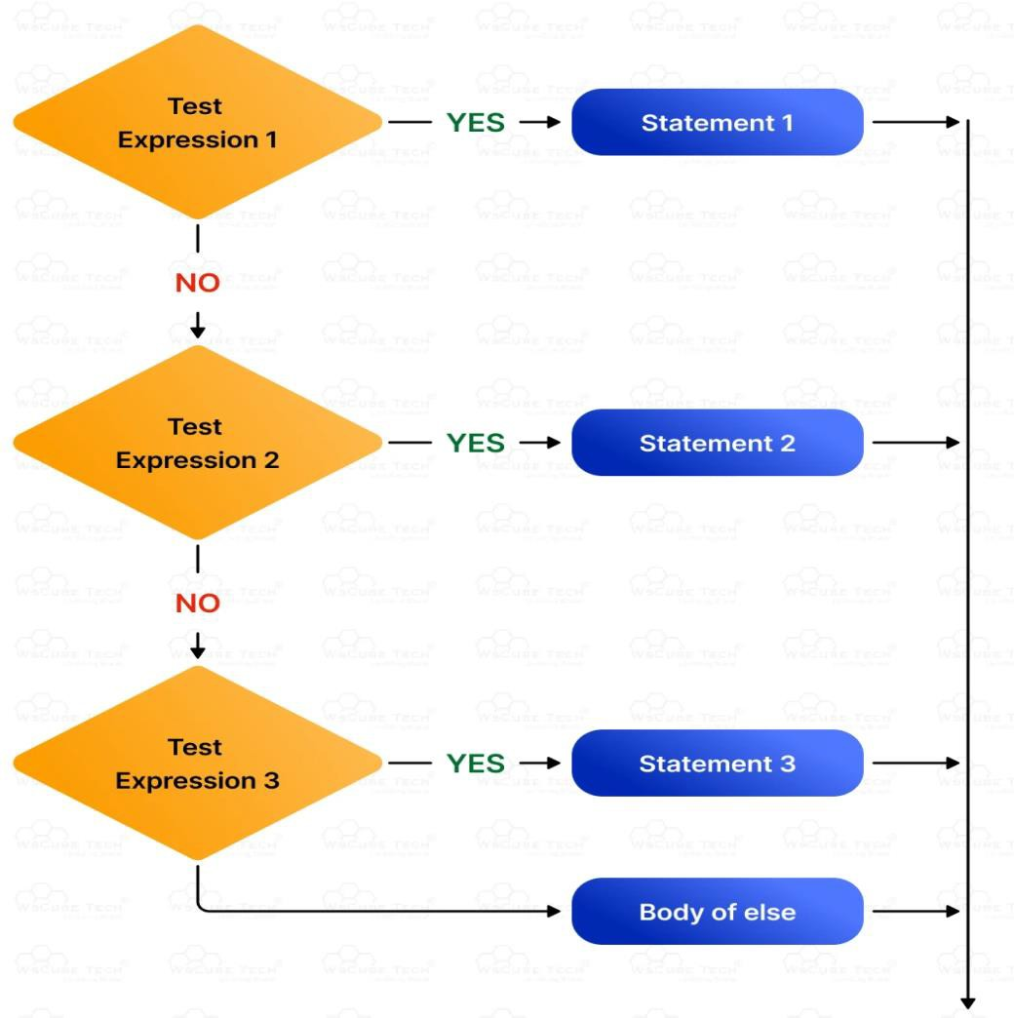Figure 3: Flow chart of elif condition in python
No

Ternary Expression [4]:
  - The ternary operator allows us to write a Python conditional statement in one line.

  - helps to decide what value to return based on a condition, making the

code shorter and cleaner.

  - There are two types of ternary expression used in python:
- Shorthand if
- Shorthand if-else

Shorthand if in Python
  - It is used when one want to return a value if a condition is true, and do

nothing otherwise.

  - Syntax:
  - if expression: statement

Example:
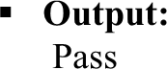
  - score = 78
if score >= 33 : print("Pass")

Shorthand if-else:
  - used to choose between two values depending on whether the condition is true or false.

Syntax:
  - “statement1” if condition else “statement2”

Example:
  - marks = 31
print("Pass“) if marks >= 40 else print("Fail“)

Output:
  - fail

Nested if..else [4]
- it means an if-else statement inside another if statement.
- is used when one need to check a condition inside another condition.

Syntax:
- if (condition):
if (condition):
statement1 #this statement will execute only if the condition is true
else:
statement 2 # this statement will execute only if the condition is false

else:
statement3 #this statement will execute only if the condition is false

Sol.
- age=71
if age<65:
if age<18:
print("Minor")

else:

else:

print("Adult")

print("Senior Citizen")

Output:
- Senior Citizen

Looping [5]
  - refers to the repeated execution of a block of code

help us run the same block of code multiple times

  - use them to repeat tasks without rewriting code, making the program shorter, faster, and easier to manage

  - Python offers the following types of loops [5]:
    - For loops (counting through items)
    - While loops (based on conditions)

For Loop [5]:
    - allow to execute a block of code repeatedly,

    - also used to iterate over a sequence such as a list, tuple, string or dictionary

Syntax 1:
    - for variable in range(starting index, ending index) statement to be executed

Syntax 2:
- for variable in range(number of iteration): statement to be executed

Syntax 3:
- for variable in range(starting index, ending index, increment) statement to be executed
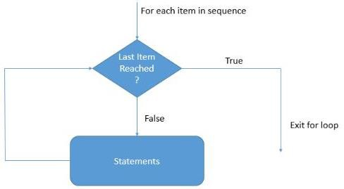
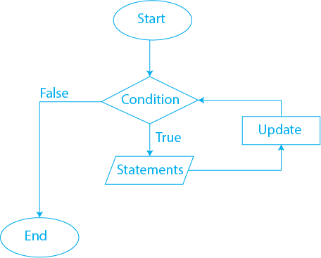

Figure 2.3: Control flow of for loop

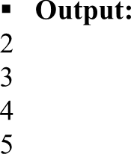
  - Example 1:
- for i in range(2,6): print(i)

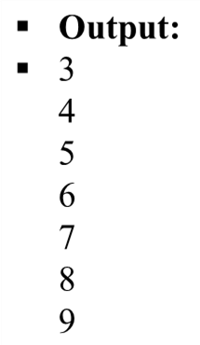
Example 2:
- n = 10
for i in range(3,n): print(i)

Printing the range of values at fixed interval:
- while range() function defaults to increment the sequence by 1, however it is possible to specify the increment value by adding a third parameter:

Syntax:
- range(starting value, ending value, value to be incremented)

Example 4:
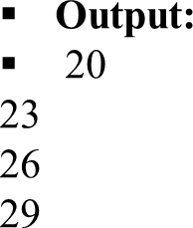
- for x in range(20, 30, 3):
print(x)

Example 1:
- for i in range(5):
print(“Hello Word”)

Example 2:
- n = 6
for i in range(n): print("Hello World")

Example 3:
- n = input("Enter n:") for i in range(int(n)): print("Hello World")

Looping [5]

Output:
- Hello Word Hello World Hello World Hello World Hello World

Output:
  - Hello World Hello World Hello World Hello World Hello World Hello World

Output:
  - Enter n:2 Hello World Hello World

  - it is also used to iterate over a sequence (List, Tuple, Set, and Dictionary) and

print all its value

  - Syntax:
for variable_name in seqeuence_name:
print(variable_name)

Example 1: (for printing data of list)
  - li = ["apple", "banana", "mango"]
for x in li:
print(x)

Example 2: (for printing data of tuple)
  - tup = ("orange", "mango", "grapes") for x in tup:
print(x)

Output:
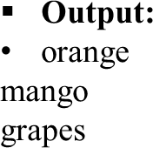
  - apple banana mango

Example 3:
  - set1 = {10, 30, 20}
for x in set1:
print(x)

  - Printing the data of dictionary:
  - For printing keys:
  - Example 4:
  - d = {'name': 'Alice', 'age': 30, 'city': 'New York'}
for x in d:
print(x)

For printing values:
  - Example 5:
  - d = {'name': 'Ekta', 'age': 57, 'city': 'Mumbai'} for a in d.values():
print(a)

Output:
  - 10
20
30

Output:
    - name Age city

Output:
    - Ekta 57
Mumbai

Looping

For printing both keys and values:
- d = {'name': 'Alice', 'age': 30, 'city': 'New York'} for a, l in d.items():
print(f"{a}: {l}")

Output:
- name: Alice
- age: 30
- city: New York

Looping

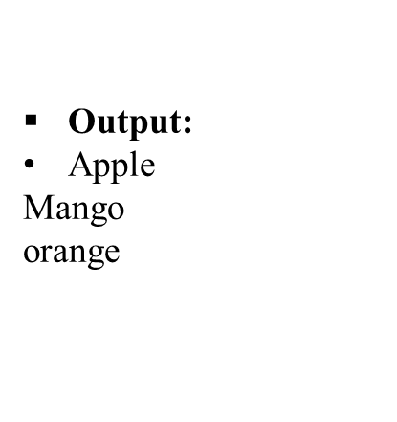Iterating by Index of Sequences [4]
- one can also use the index of elements in the sequence to iterate.

Example 1:
- li = ["apple", "mango", "orange"]
for k in range(len(li)): print(li[k])

Example 2:
- tup = ("apple", "mango", "orange")
for k in range(len(tup)): print(tup[k])

Output:
- apple Mango orange

set cannot be iterated by the index of the sequence, as its order has not been
defined.

- Nested for loops [5]

Looping

- A loop can also contain another loop inside it. These loops are called nested loops.

- In a nested loop, the inner loop is executed once for each iteration of the

outer loop.

- Program code:
- attributes = ['Electric', ‘Diseal']
cars = [‘Suzuki', ‘Hundai', 'Mahendra & Mahendra'] for k in attributes:
for l in cars:
print(k, l)

Output:
- Electric Suzuki Electric Hundai Electric Mahendra & Mahendra
Diseal Suzuki Diseal Hundai Diseal Mahendra & Mahendra

  - While Loop [5]

Looping

  - is used to execute a block of statements repeatedly until a given condition is satisfied.

  - when the condition becomes false, the execution stops, and line immediately after the loop in the program is executed.

  - Syntax:

while condition:
statement

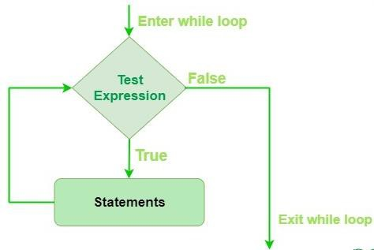

Figure 1.2: Flow control of while loop

- Example:
- a = 0
while a < 4:
a = a + 1

Looping

Output:

- Hello World Hello World Hello World

indented
print("Hello World")
Hello world

Loop control statement in python [5]:
- Following are some of the loop control statement:
  - Break
  - Continue
  - Pass

  - The break Statement:
- use to stop the loop before it iterate on all the data

- Example 1:
- for i in range(1,10):
if i==4:
break else:
print(i)

Looping

Output:
- 1
2
3

Example 2:
- fruits = ["apple", "banana", "cherry", "orange", "mango", "guava"]
for x in fruits:
if x == "orange":

break else:
print(x)

Output:
- apple banana cherry

- The continue Statement

Looping

use to stop the current iteration of the loop, and continue with the next

- Example 1:
- for i in range(1,10):
if i==4:
continue
else:
print(i)

Output:
- 1
2
3
5
6
7
8
9

Example 2:
- fruits = ["apple", "banana", "cherry", "orange", "mango", "guava"] for x in fruits:
if x == "orange":
continue
else:
print(x)

Output:
- apple banana cherry Mango guava

  - Pass:
Looping

used to skip performing any execution at a specific iteration, while still executing the rest of the code.

  - Example 1:
  - for i in range(1,10):
if i==4:
pass
else:
print(i)

Example 2:
  - Output:
- 1
2
3
5
6
7
8
9

  - fruits = ["apple", "banana", "cherry", "orange", "mango", "guava"] for x in fruits:
if x == "orange": pass
else:
print(x)

Output:
- Apple
- Banana
- Cherry
- Mango
- guava

THE END

